

CHRISTMAS IN LLANDUDNO

Trip notes

**_________________________________________**

**Christmas in Llandudno**

**Enjoy an Ads Ventures Christmas in an elegant seaside location nestled between excellent walking territory on the headlands of the Great and Little Orme and beyond into Snowdonia.**

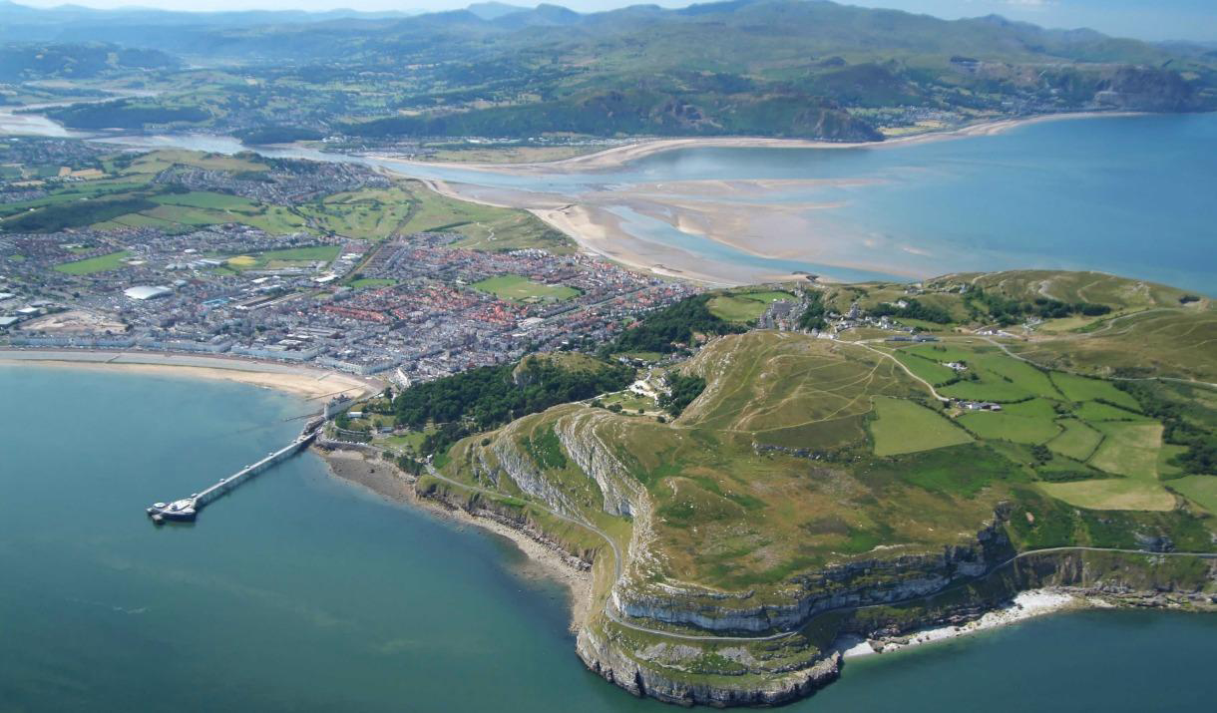

* 4 nights half-board accommodation in the 3 Star Marine Hotel, with walks on Christmas Eve, Christmas Day and Boxing Day
* Departure date: December 23rd 2024
* Cost: from £695
* Single room supplement: from £80 – lots of upgrades to view and superior rooms available
* Grade 

Llandudno’s appearance has remained unchanged for over a century leaving an attractive seaside resort with a promenade of Victorian pastel-coloured hotels and an elegant pier.

However, the real joy of Llandudno is its location. It is perfectly framed by 2 headlands, the Great and Little Orme. These themselves offer excellent walking and, with the Snowdonia National Park only a stone’s throw away, the ingredients of a superb Christmas break are on the doorstep.

**Holiday highlights**

* Walk sections of the North Wales path and spot seals from the Little Orme - a classic Boxing Day activity.
* Climb the majestic Conwy Mountain (not really a mountain at 244 m) to explore the remains of an Iron Age settlement and enjoy fantastic views out to sea.
* Explore the nature and history of the Great Orme on Christmas Day.
* Stay in the elegant Victorian seaside resort of Llandudno and enjoy a festive Christmas in the Marine Hotel.

**Accommodation**

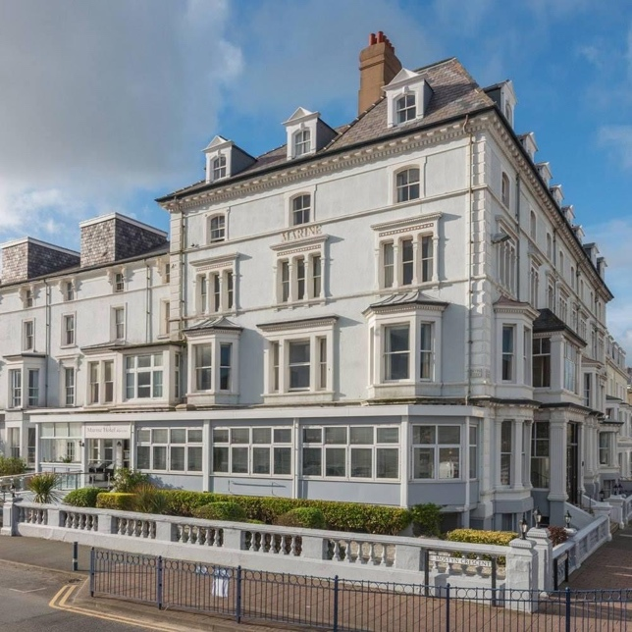Our home for this Christmas Break is the ideally situated Marine Hotel in the heart of Llandudno’s Victorian promenade. Many of its comfortable rooms and lounges have sea views. You can also relax in the hotel’s swimming pool at the end of the day’s walking.

As well as excellent walking, the holiday will be complimented with Christmas activities in the hotel, including festive cream teas, a full lunch on Christmas Day and a welcome drink on the day of arrival.

All rooms are comfortable and ensuite and have tea and coffee making facilities. Room upgrades to a larger room or those with a sea view are possible, and I have several of these available. Please enquire if you are interested.

**Single supplements and upgrades**

* Single occupancy supplement: £80
* Sole occupancy of a double room: £120
* Double room with sea view: £120 (per room)
* Sole occupancy of a double room with sea view: £200
* Superior double room with a sea view: £180 (per room)
* Sole occupancy of a superior double room with a sea view: £260

**Included**

* En-suite half-board accommodation in comfortable en-suite rooms in the Marine Hotel.
* Breakfast each morning and a three-course evening meal each evening, served in the hotel restaurant.
* Christmas Day Lunch
* Full day walks on Christmas Eve and Boxing Day and a morning walk on Christmas Day with a qualified and professional leader.

**Not included**

* Lunches on Christmas Eve and Boxing Day. These can be bought locally or ordered from the hotel.
* Incidental expenses such as drinks.
* Transport to one of the walks. This a short drive away.

**Detailed Itinerary**

The following is the proposed itinerary. However, please bear in mind that in the event of local conditions changing, for example due to weather or other unforeseen circumstances, it may be necessary to change the itinerary.

**Monday December 23rd**

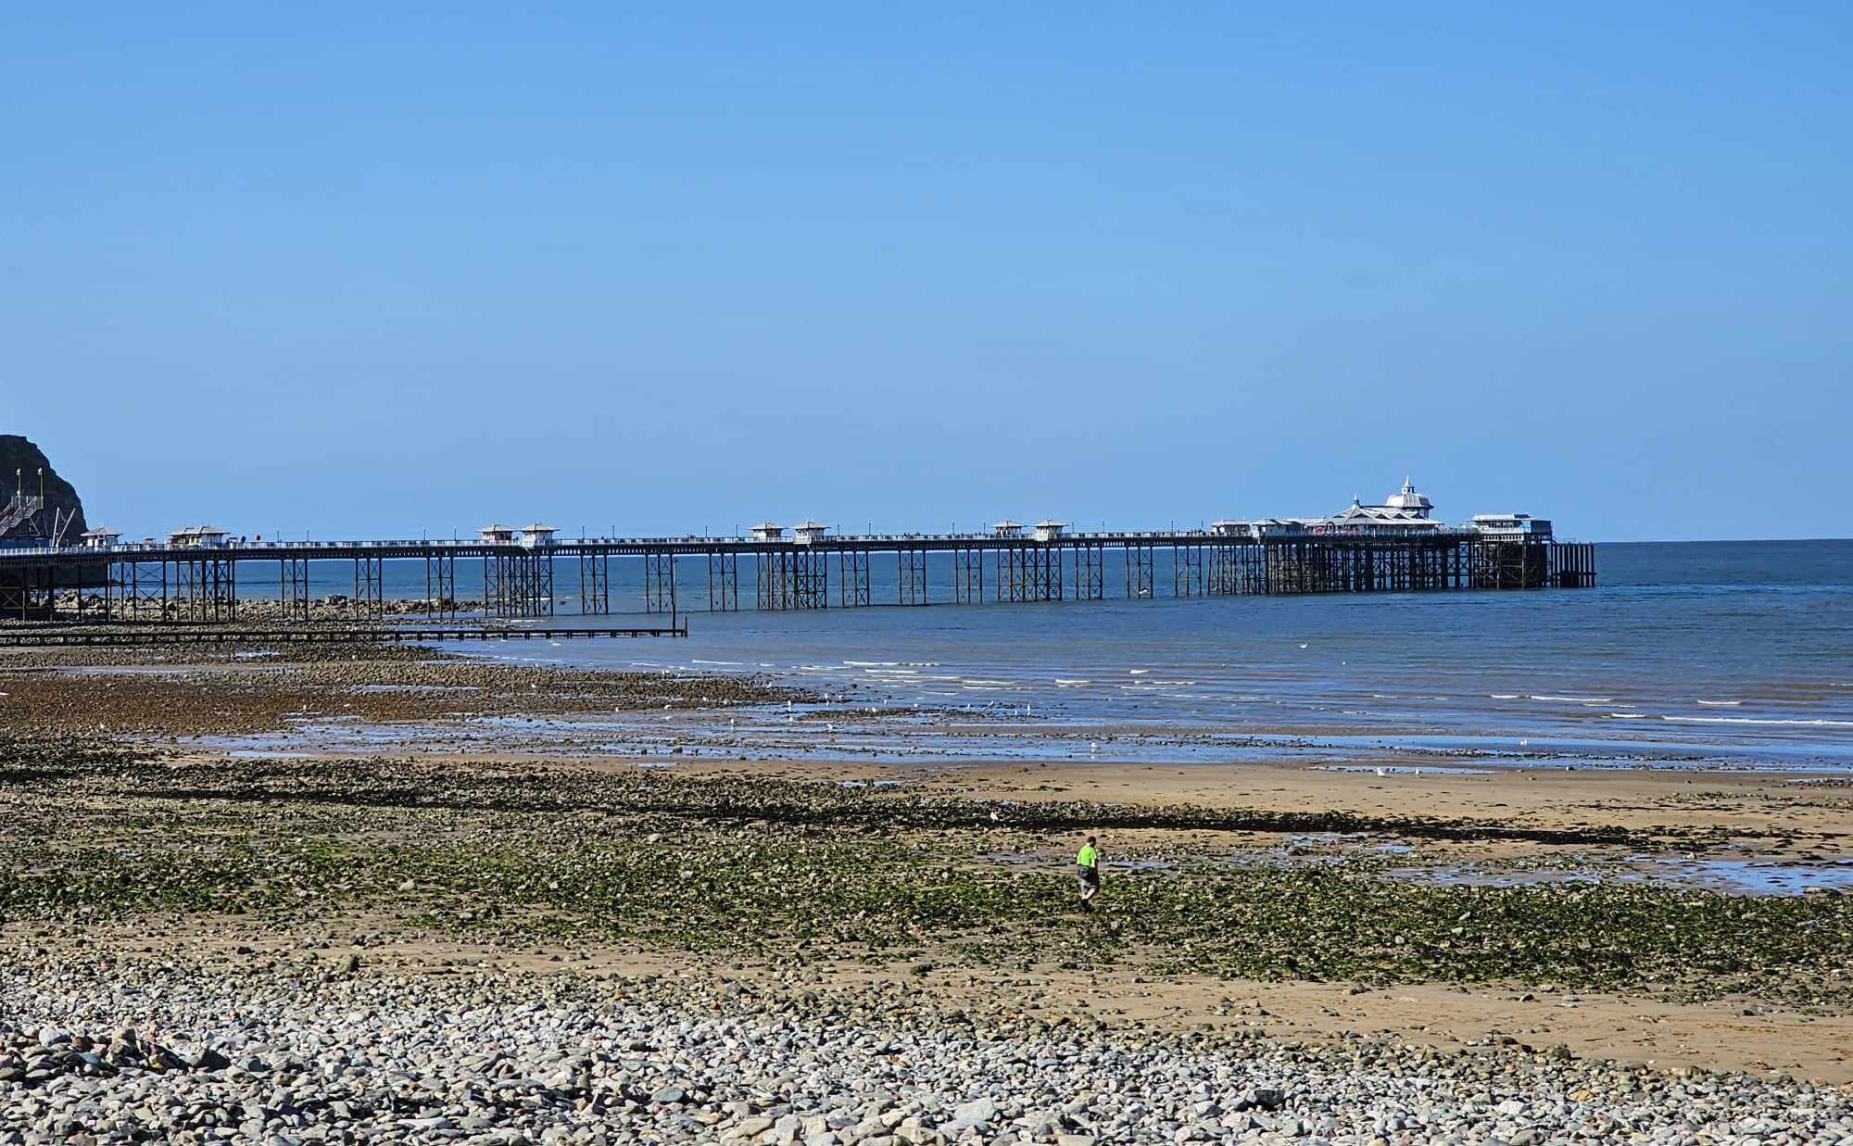

Arrive at the Marine Hotel and check into your room. Meet at 7pm for a short briefing about the week ahead before our three-course dinner is served in the hotel’s restaurant.

**Meals included: dinner**

**Christmas Eve: Conwy Mountain**

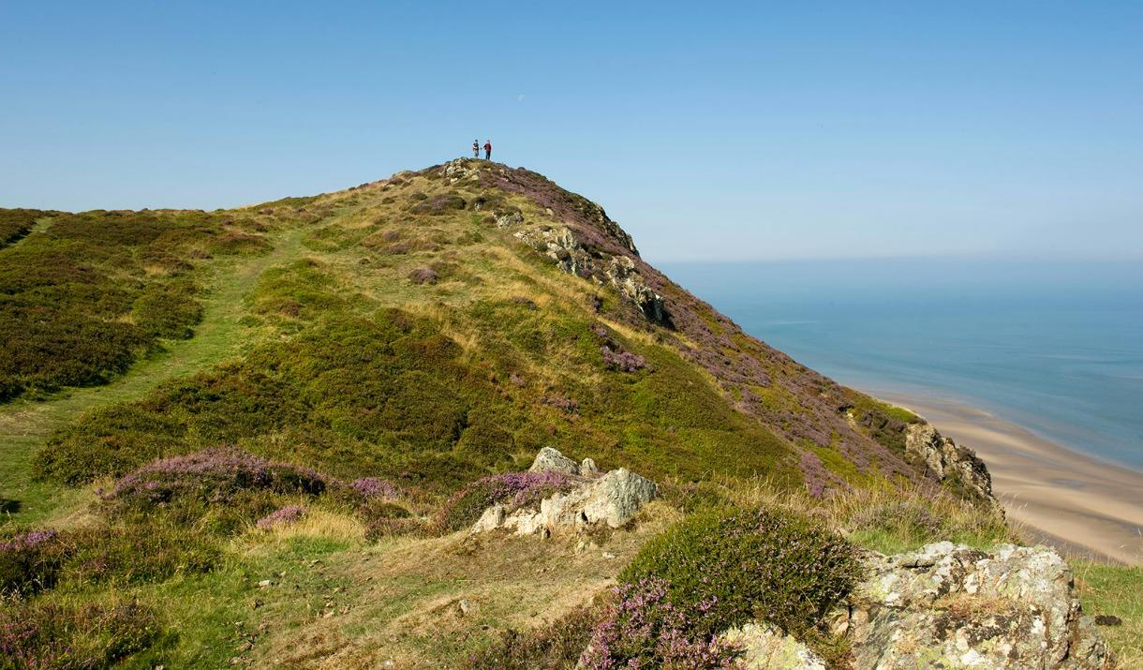Today, we drive the short distance (approx. 5 miles) to park in Conwy for a walk that combines sections of the Cambrian Way, and the North Wales path. We follow the waterfront out of town and then gradually climb to the summit of Conwy Mountain (244 m) to take in views across the Great Orme and sea beyond as well as along the Conwy Valley. We cross the Sychnant pass and pick up moorland paths across to Llechwedd and then a series of quiet country lanes and tracks to return back through the walls of the old town to our starting point.

**14.5 (9 miles) ascent/descent 500 m**

**Meals included: breakfast and dinner**

**Christmas Day: The Great Orme**

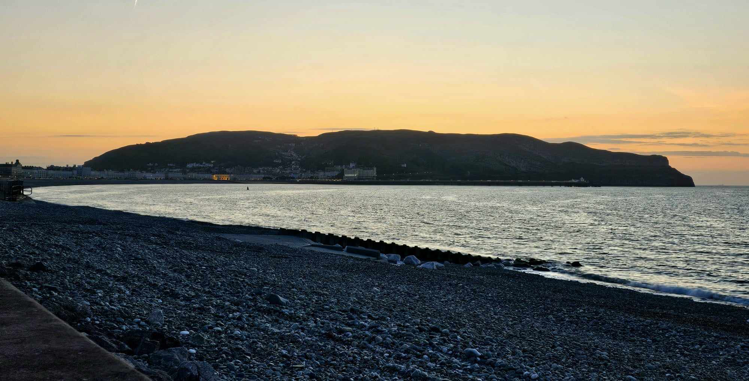The Great Orme dominates the viewline from the hotel, and today we set out to explore it.

Leaving town, we pass through the Botanical Gardens to 12th century St Tudno’s church as we head up onto the Great Orme. We follow a track tracing the wall that once enclosed the highest land of the Great Orme and as it rounds the headland views over to the Carneddau mountains and Anglesey open up. After taking these in we turn south and return via Bishops Quarry to the hotel for our Christmas Lunch.

**8 km (5 miles) ascent/descent 290 m**

**Meals included: breakfast, Christmas Lunch and dinner.**

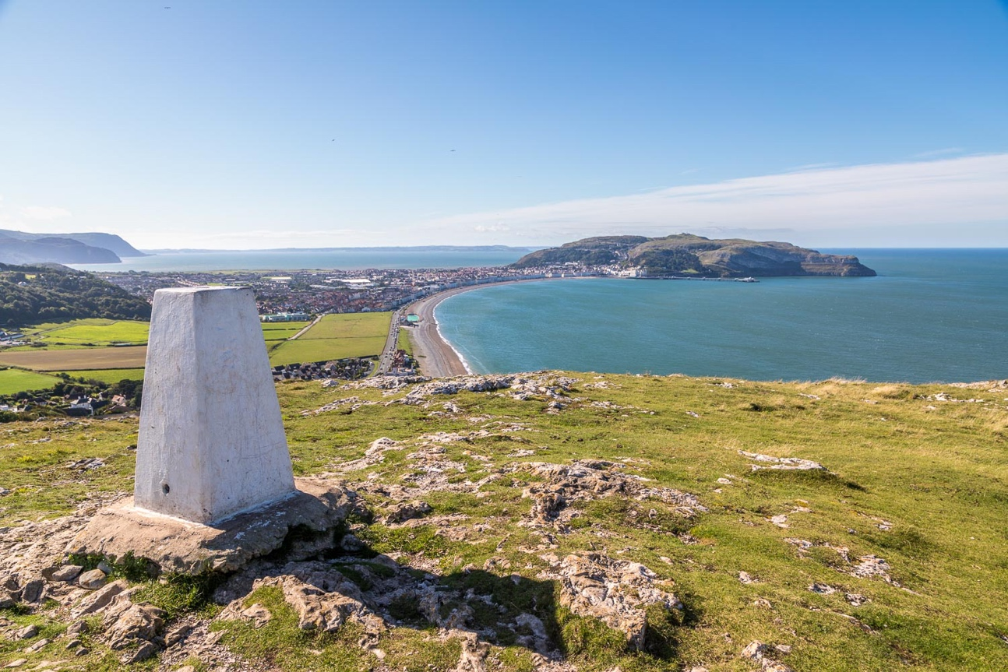**Boxing Day: Deganwy and the Little Orme**

Today we walk from the hotel to pick up the North Wales path along River Conwy before heading inland and up to Deganwy Castle and cross country to the Little Orme. From here there are views out over Llandudno Bay and, hopefully, down to the seal colonies below. From the little Orme we follow the bay and walk the length of the promenade back to the hotel.

**16 km (10 miles) ascent/descent 300 m**

**Meals included: breakfast and dinner**

**Friday December 27th: Farewells until next time!**

After a good breakfast we say goodbye, until next time.

**Meal included: breakfast**

**Kit list**

For walking each day:

* Good walking boots or shoes
* Waterproof jacket and trousers
* Lightweight, quick drying trousers
* Base layer
* Mid-layer such as a fleece jacket and an additional ‘spare’ layer depending on the forecast
* Walking socks
* Day sack (25 litre capacity is a good size) to comfortably carry your kit, lunch and water
* Dry bag or rucksack cover to keep the contents of your daypack dry
* Water bottle
* Basic first aid kit (plasters, blister treatment, antiseptic etc)
* Some snacks to keep you going
* Walking/trekking poles (if you use them)

**Maps:** OS Explorer map OL17, Snowdon/Yr Wyddfa

**Group size**

This guided holiday will have a maximum group size of 15.

**Personal expenditure**

All breakfasts, evening meals and Christmas Day lunch are included in the holiday cost.

You will need enough money to cover lunches and incidental expenses such as drinks.

**Any other queries, please get in touch with me.**